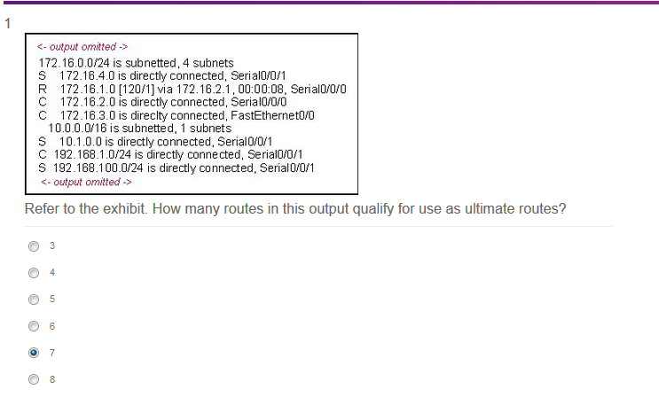

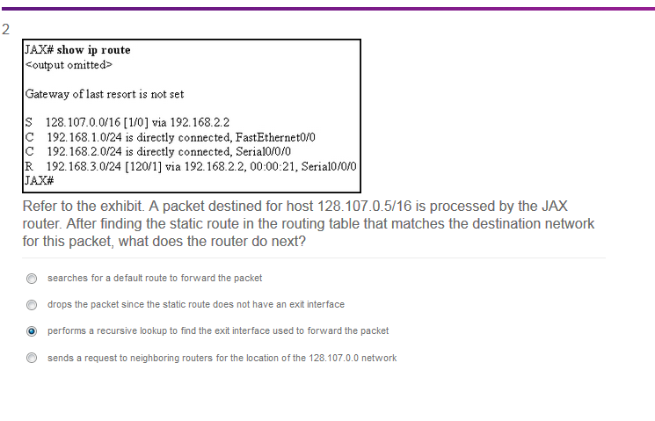

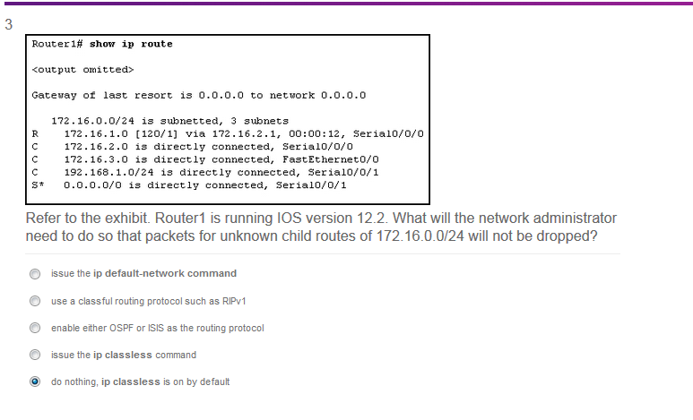

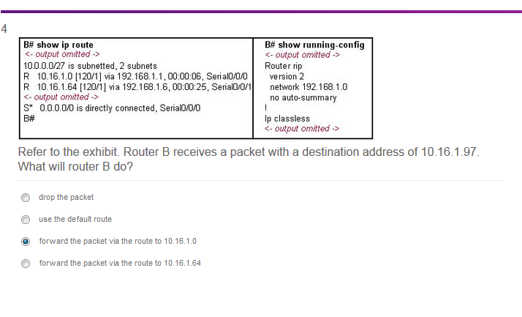

**Refer to the exhibit. Router B receives a packet with a destination address of 10.16.1.97. What will router B do?**  
drop the packet  
forward the packet via the route to 10.16.1.0  
forward the packet via the route to 10.16.1.64  
use the default route

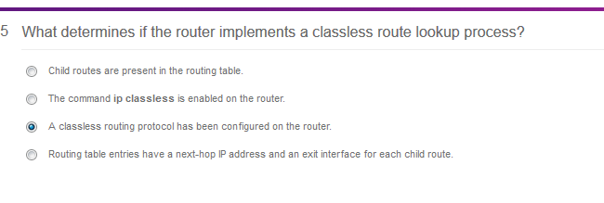

**6**. **What determines if the router implements a classless route lookup process?**  
Child routes are present in the routing table.  
A classless routing protocol has been configured on the router.  
The command ip classless is enabled on the router.  
Multiple routes with different masks to the same destination are in the routing table.  
Routing table entries have a next-hop IP address and an exit interface for each child route.

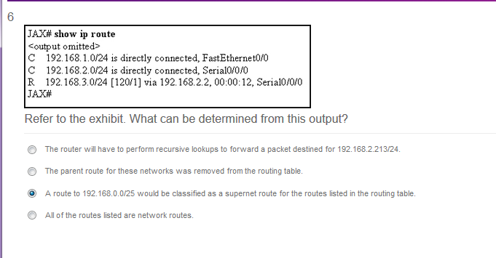

**Refer to the exhibit. What can be determined from this output?**  
The router will have to perform recursive lookups to forward a packet destined for 192.168.2.213/24.  
The parent route for these networks was removed from the routing table.  
A route to 192.168.0.0/25 would be classified as a supernet route for the routes listed in the routing table.  
All of the routes listed are network routes.

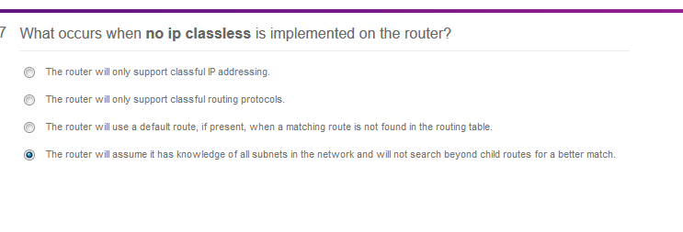

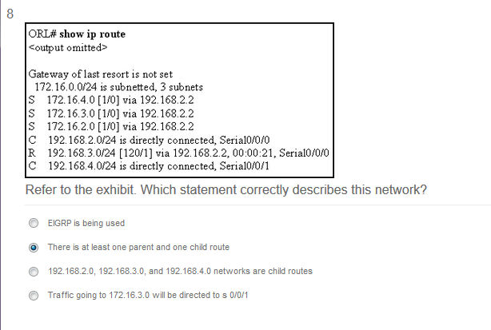

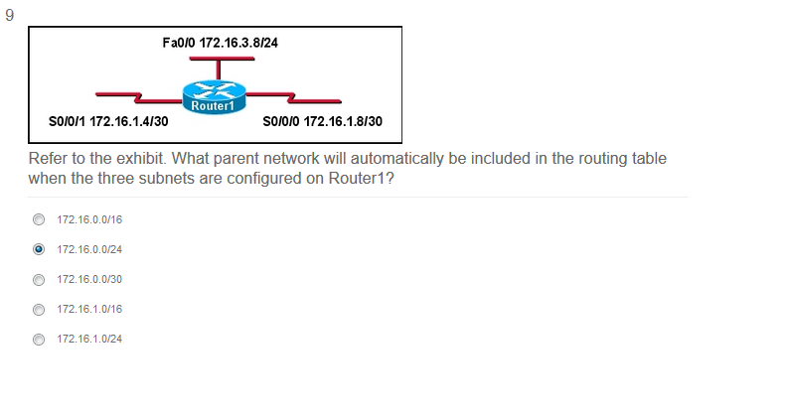

**Refer to the exhibit. What parent network will automatically be included in the routing table when the three subnets are configured on Router1?**  
172.16.0.0/16  
172.16.0.0/24  
172.16.0.0/30  
172.16.1.0/16  
172.16.1.0/24

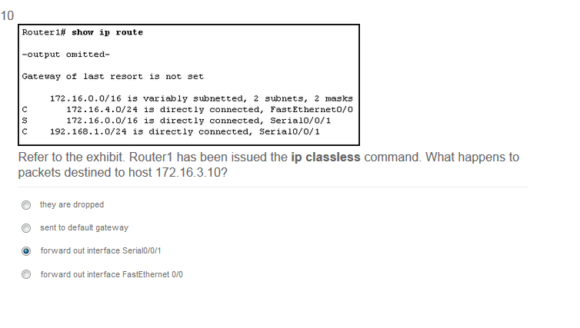

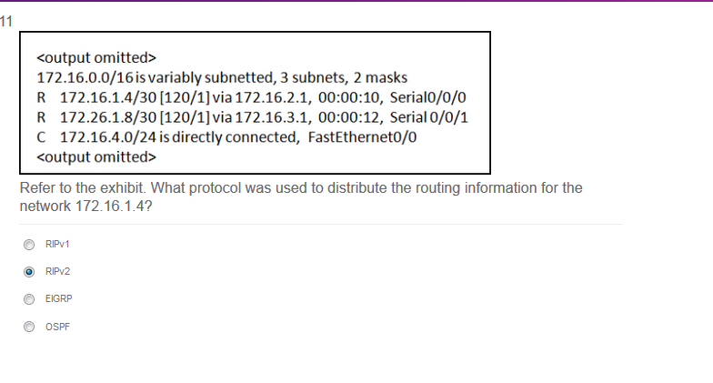

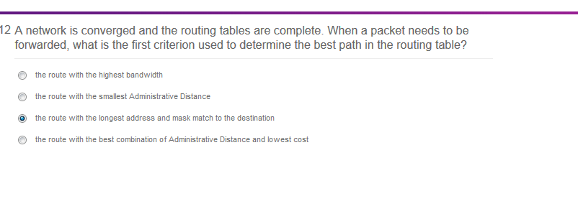

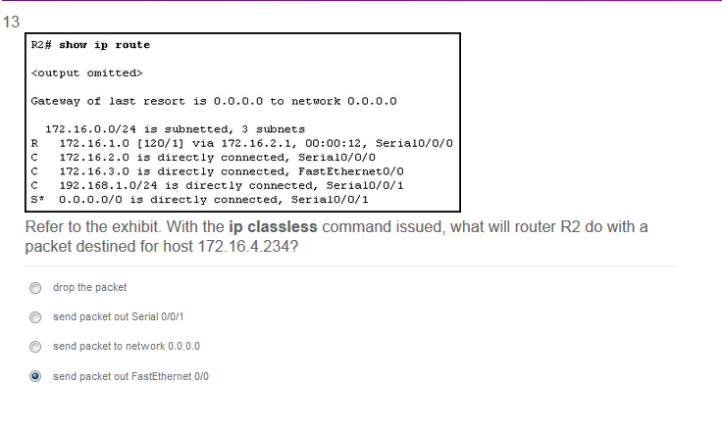

[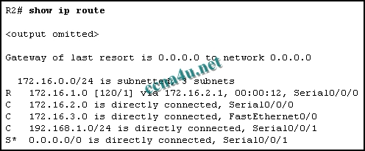](http://answers.ccna4u.net/wp-content/uploads/2011/02/082.jpg)

**Refer to the exhibit. With the ip classless command issued, what will router R2 do with a packet destined for host 172.16.4.234?**  
drop the packet  
send packet out Serial 0/0/1  
send packet to network 0.0.0.0  
send packet out FastEthernet 0/0

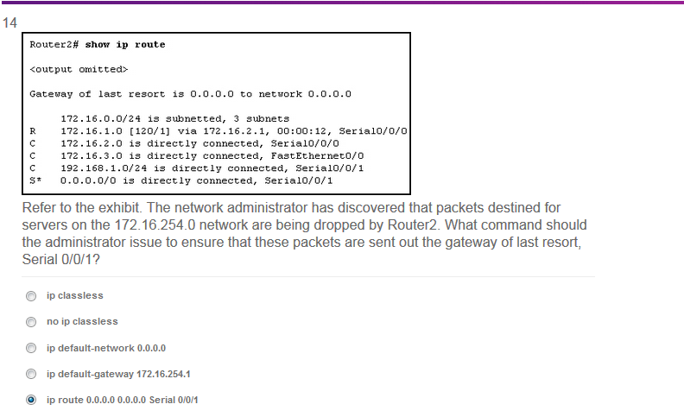

**Refer to the exhibit. The network administrator has discovered that packets destined for servers on the 172.16.254.0 network are being dropped by Router2. What command should the administrator issue to ensure that these packets are sent out the gateway of last resort, Serial 0/0/1?**  
ip classless  
no ip classless  
ip default-network 0.0.0.0  
ip default-gateway 172.16.254.1  
ip route 0.0.0.0 0.0.0.0 Serial 0/0/1

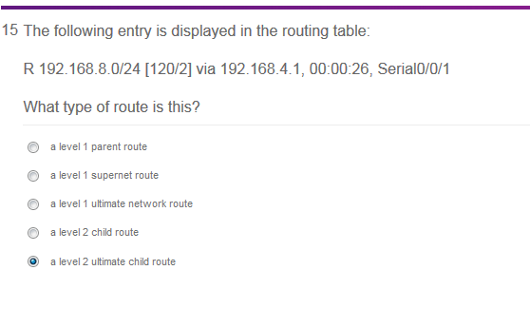

**5**. **The following entry is displayed in the routing table:  
R 192.168.8.0/24 [120/2] via 192.168.4.1, 00:00:26, Serial0/0/1  
What type of route is this?**  
a level 1 parent route  
a level 1 supernet route  
a level 1 ultimate network route  
a level 2 child route  
a level 2 ultimate child route

